SCT Sunday Service Testimonials
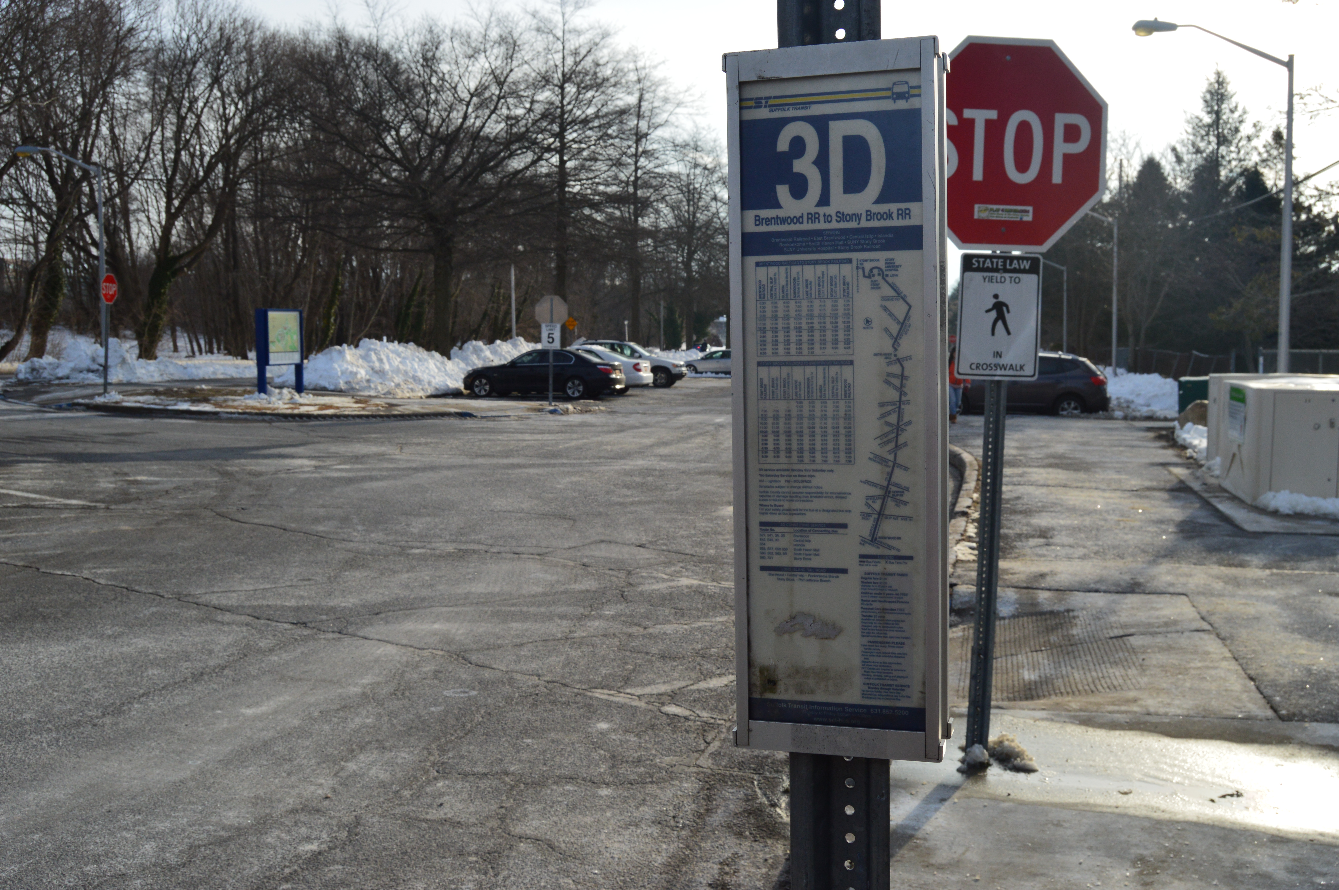
A report on the impact of Sunday bus service in Suffolk County

A collaborative work of Long Island Jobs with Justice, the Long Island Bus Riders’ Union and TRI-State Transportation Campaign
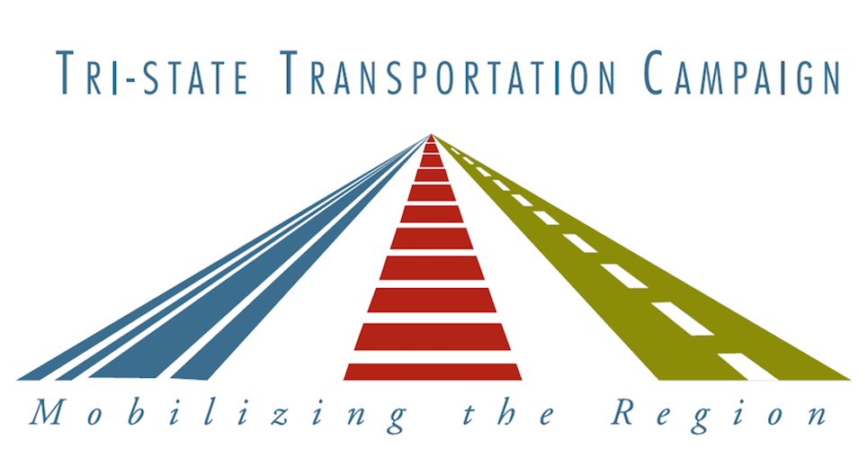
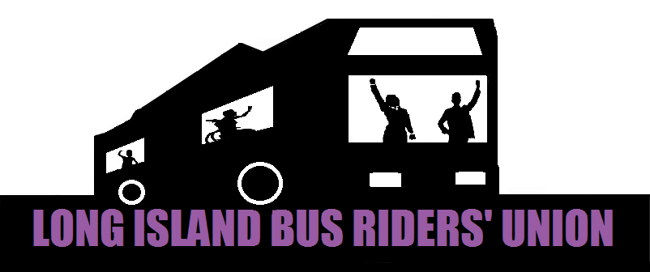
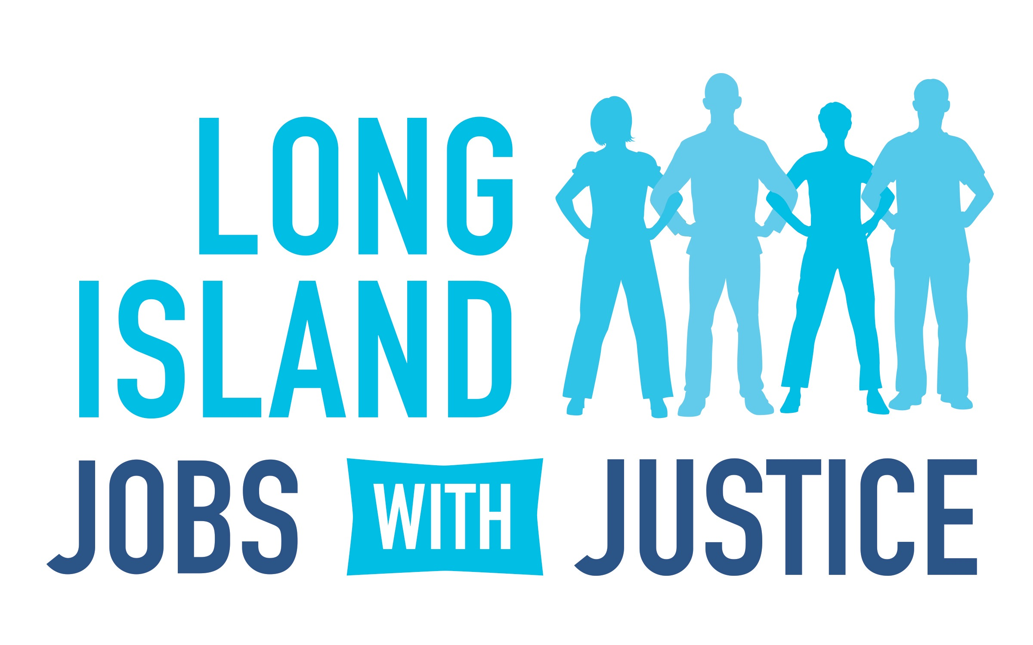

INTRODUCTION
Suffolk County receives far less in State Transit Operating Assistance (STOA) for its bus system when compared to neighboring Nassau and Westchester Counties. New York State’s funding contributions only make up roughly 30 percent of Suffolk County Transit’s operating budget, while comprising over 50 percent and 40 percent of the operating budgets of Nassau Inter-County Express (NICE) and Westchester’s Bee Line service, respectively. To begin to make up for this imbalance, Suffolk County should receive $10 million more in additional STOA funding.

When Suffolk County receives additional funding it puts it to its intended purpose. In 2013, Suffolk County received roughly $2 million in additional state and federal transit funding. This funding was dedicated to the expansion of Sunday service along 10 routes with the highest ridership. Those routes consisted of the following: S1, S33, S40, S41, S54, S58, S66, S92, 3D and 10C. Since launching in January 2014, this service as proven tremendously popular. Through mid-June of this year, ridership on these routes had grown by almost 200 percent and by the end of the year majority of the new Sunday lines saw ridership increase by 300 percent to 600 percent.
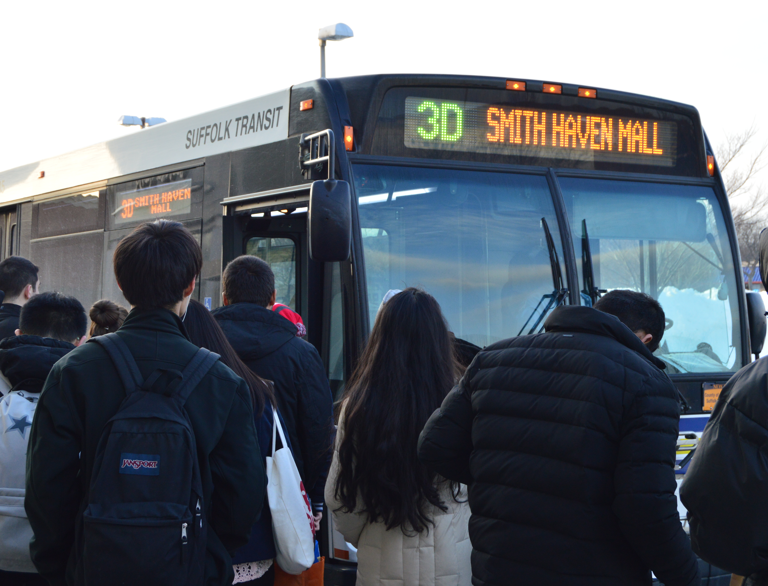
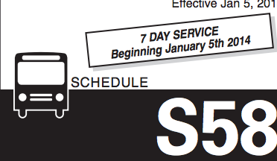
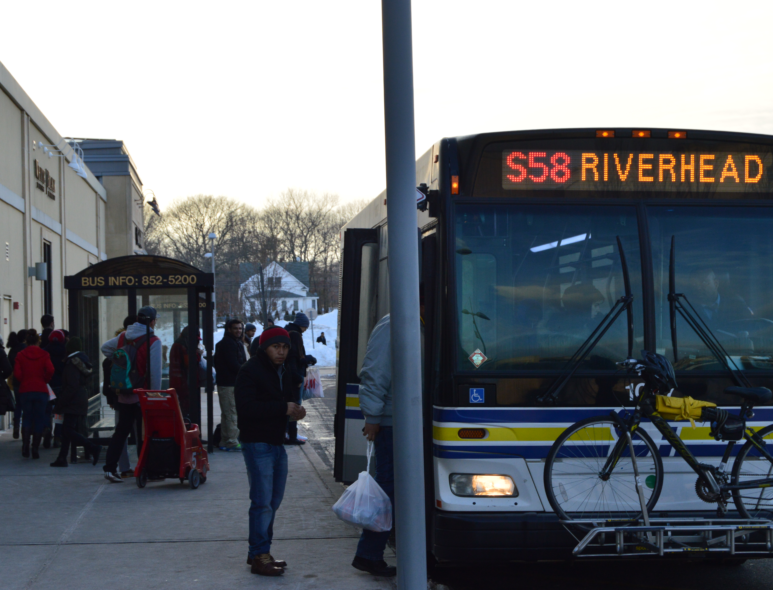
Suffolk County bus service is increasing in popularity. In 2013 alone, nearly 6.5 million trips were taken on Suffolk County Transit. According to the National Transit Database, ridership on Suffolk County Transit has increased by approximately 30 percent since 2000.

Bus service on Long Island is a boon for the economy. A recent economic impact analysis conducted by Appleseed, Inc. and New York University’s Rudin Center for Transportation Policy and Research found that bus service in Nassau County accounted for approximately 1,490 jobs and $191.5 million in economic output in 2012. Closer to home in Suffolk County, Tri-State Transportation Campaign found that 30 driver and mechanic jobs were created as a result of the $2 million in state and federal funding invested into Sunday service that began in 2014.

It is apparent that more service is needed. Despite these gains in ridership and service improvements, over 80 percent of the system lacks access to Sunday service, which in turn, prevents Suffolk County Accessible Transit (SCAT) from operating as well. Federal law requires that on-demand para-transit service be offered within a quarter of a mile of fixed-route bus service. In the areas that do not have Sunday service, para-transit service is not provided to Suffolk County residents that day of the week. In addition, the Suffolk County Welfare to Work Commission has recommended that bus service also be expanded further into evenings, a service that does not exist past 8 pm on a majority of routes. Although implementation of Sunday bus service provided some commuters with an alternative to more costly modes of transportation, like taxis and personal vehicles and also expanded access to major business centers, like local downtowns and malls, and to employment and employment opportunities, there are still many residents who cannot access the service.

The purpose of this report is to highlight actual bus rider testimonies to demonstrate the effectiveness of Sunday service while also supplementing recommendations on how to further grow the system. Rider testimonies provide insight into the real life situations and experiences that occur when utilizing a public transportation system and should be used when discussing large service changes to any public system. It is our hope that this report will act as a supplement to assist in advocating for additional State funding that will help expand and maintain SCT.

BUS RIDER TESTIMONIES
Before the implementation of Sunday service, many residents who solely relied on public transportation were limited to where and when they could travel; however, with its introduction, bus riders have witnessed their access to many services, jobs, and consumer options expand. The following statements are a collection of Sunday bus rider testimonies that reveal the opportunities Sunday service has provided and the unmet needs that still remain.

Gary Davis rides the S29. He is a member of the Upper Room Christian World center and is an avid bus rider and attends church regularly. His testimony demonstrates how inactive bus lines in Suffolk affect the community:

“I've had good experiences with SCT and I was thrilled to heard about Sunday service but I realized there was an S29 bus stop outside of my church that was inactive. My church serves a lot of communities that can't access our services due to transportation challenges. I'm a bus rider who has never been able to get to church without assistance from others. There is a pent up, unsatisfied need for Sunday service for the S29, if expanded it would be a 'win-win' for all involved”

Sunday service has helped riders like Angela Gloudon; however, at times she is still forced to rely on her bike to get her around:

“I'm happy the S66 runs on Sundays now, I just wish there were more buses on Sunday and at night. I take the bus to go shopping and since the S68 doesn't run on Sundays I have to ride my bike to the nearest bus stop, which makes it hard to get around, especially in the winter.”

Lee Ann rides the 7B and S66. She is a single mother with a two-year old child who rides the buses to take her daughter to programs and classes. They currently live at Help Suffolk, a shelter for transient or homeless individuals:

“I schlep with a child, a stroller, groceries and with my back issues. Accessibility is a major concern. My daughter and I are technically 'homeless' and though I can get to places, like programs and classes for her at the library, getting back is almost impossible. Her programs have been running later and later and with this weather I can't afford to walk.”

As required by the Americans with Disabilities Act (ADA), para-transit services can only operate along existing and running fixed route lines. Before the implementation of Sunday service, those who relied on SCAT (Suffolk County Accessible Transportation) were homebound, unable to leave their residences unless they found other means of transportation. Suffolk County has over 280,000 residents with disabilities (Suffolk County), 30,000 more than Nassau County. The development of Sunday service provided expanded freedoms and opportunities for disabled residents.

Cliff rides the S66 and lives with Diabetes. His illness forced him to become dependent on public transportation. The implementation of Sunday service on his bus route changed his life. This is Cliff’s testimony:

“I am so grateful for Sunday service. Due to my severe Diabetes, I was forced to stop driving early and rely on the buses to get everywhere. It wasn't until the new Sunday service that I was even able to spend time with my son on the weekends. It's because of the Long island Bus Riders' Union that I can finally take him to the movies or teach him how to fish and his mother can finally have some time to herself. I get an extra day to spend with my son without the fear of not having a ride to get him home on Sunday or to school on Monday, and it's all thanks to the Bus Riders' Union.”

Kenneth Noelsch Jr. is a disabled bus rider who lives in Central Islip. His testimony is reflects on the limitations that continue to exist for disabled bus riders:

“I lost my car about 15 years ago due to issues with my legs. I ride the bus almost everyday but I can't access Sunday buses because the nearest stop is over a half a mile from my house and I can't get there. The Sunday service is a good idea but I don't feel like its being operated efficiently.”

There is a direct correlation between access to public transportation and an individual’s access to employment and educational opportunities (Graves). Bus riders who work in retail and food service jobs, like clothing stores and supermarkets, are often required to work flexible or late hours on the weekends. Before Sunday service, many workers needed to find alternative means of transportation (ex. calling a taxi service) that are often more expensive than public transportation.

Sarraline Bahomnde is a Veteran who works on the weekends at the Smithhaven Mall. She is also one of thousands of individuals who cannot access Sunday bus service:

“The Sunday service is good to get to the [Smithaven] Mall but only if you're near a stop. When I work on Sundays I either have to walk over an hour from my house in Centereach to the nearest 3D bus stop or pay $15 for a taxi. Neither is great, especially since I was almost hit by a car while walking to the bus stop...but what can I do?”

Walter rides the S92. He is a worker at a local supermarket who struggled to get to work on Sundays:

“The buses, from what I've seen, have been getting better! They're more convenient and even run on Sundays now. I usually work on Sunday, so this has made my life so much easier. I've even started telling my friends that they should ride the bus too and stop wasting all that gas. It’s not perfect though. I wish the buses would run later at night. I would like to work more night hours but I can't unless I find a ride from a co-worker.”

IMPACT ON LONG ISLAND COMMUNITIES
Many community organizations like Vision Long Island, who represents the Long Island Business Council and the Long Island Smart Growth Working Group, are in support of Sunday service expansion. At a time when communities are looking to lower their carbon footprint and provide support to small businesses, we need to focus on the ways that we can highlight Suffolk County as a destination. Transportation systems that provide service everyday of the week are vital to this growth.

Eric Alexander, Director of Vision Long Island, has worked with many local business owners and community members around the expansion of service in Suffolk County. Vision Long Island advances more livable, economically sustainable, and environmentally responsible growth on Long Island through Smart Growth. He contributed this testimony about Sunday service:

“We believe that this increase in service is crucial for a substantial number of riders. Currently many riders cannot rely on the bus to get home from jobs that have evening hours or require them to work on Sundays, which many service jobs do. Instead they rely on cabs or other means of travel. This increase will cost less to those riders than cab fare or having to forgo shifts or better paying jobs because they would not have reliable transportation to get there.

Sunday service would provide an improvement in the quality of life for many of its riders including the low to moderate income, seniors, millennials, disabled, and veterans who rely on bus service as their main source of transportation. The service not only allows for employees to get to work on Sundays, it also allows access for customers to patron many of our small businesses. Many of the Sunday riders would also rely on the service to attend church services. Without Sunday service, seniors who rely on the bus for social activities are left with no way to get around.

Particularly important to remember, bus services are generally the only form of North/South connectors for public transportation throughout Suffolk County. The buses also connect our downtowns and allow for commuters to travel throughout Suffolk without relying on other forms of transportation. However, the system lacks the convenience of evening and Sunday service for Suffolk County residents as well as access for our neighbors to the west in Nassau County.”

Samantha is a manager at Hallmark in the Smithhaven Mall and although she is not a bus rider she has several employees who ride the bus:

“I don't use the buses but I've definitely noticed a difference. There is more traffic going into the mall on Sunday's than ever.”

Steven Siegalwaks is the owner/proprietor of Green Earth Natural Foods Market in Riverhead. He also was not a bus rider but was aware of its expansion and positive impact:

“I don't really deal with the buses but I have heard that it's been getting better. I think for a place as big and shaped the way Long Island is, it's imperative that we continue to grow the buses and I hope that they do keep expanding and adding more service.”

Legislator Jay Schniederman, who represents Suffolk County District 2, was instrumental in the development of Sunday service in both 2011 and 2013. As a local elected official he has seen the positive effects of Sunday service in his community and understands the importance of a robust, affordable and effective public bus system:

“Public transportation is essential. ‘No bus’ means ‘no work’ for many people. Not everyone can afford car payments, insurance, repairs and gasoline. Years ago, during the days of the "blue laws", retail business were closed on Sundays. Those days are long gone. Sundays are busy working days, particularly in areas where tourism is a big part of the economy. But it was not until recently that Suffolk County began to offer limited Sunday service. Only about one out of five bus lines now run on Sundays. We've seen ridership levels grow consistently on these lines and we've had many requests to add additional lines. But the County simply doesn't have the money to bring the system up to the needed service levels. We'll be adding a few more lines this Spring with revenue from a twenty five cent fare increase, but the answer is not from fare hikes. We need additional State funds to help cover the costs of Sunday service. Many routes also need to run later into the evening so that people can get home from work.”

CONCLUSION AND RECOMMENDATIONS
Implementing Sunday bus service had, and continues to have, a significant impact on the lives of Suffolk County residents who depend on the buses to get them to work, school, doctor’s appointments and other occasions. Our conversations with bus riders, employers and community members provide a first hand account of the successes, needs and issues regarding a transit system. The previous testimonies were collected to highlight the positive impacts of service expansion on Sunday routes and to reveal the needs of bus riders that persist. While Sunday service has been a huge success, utilized by thousands, there are still many bus riders who remain without Sunday service, evening service, or no service.

KEY RECOMMENDATIONS

In order to provide accessible and efficient public transportation, the needs of bus riders should be considered by policy makers and transportation development bodies. Long Island Jobs with Justice, the Long Island Bus Riders’ Union and Tri-State Transportation Campaign have compiled a list of recommendations that would further the accessibility and efficiency of SCT, and ultimately benefit the overall economic and social health of Suffolk County.

Continue to expand Sunday bus routes. Increasing the number of bus routes running on the weekends will provide more opportunities for employment and consumer engagement.

Expand evening service system wide. Many bus riders are forced to work between certain hours of the day to accommodate for the lack of evening service. This can lead to termination, quitting or use of costly alternatives, like taxis.

Invest additional State funding in public transportation. New York State has disproportionately funded the bus systems in Nassau and Suffolk County. Suffolk County Bus has been consistently underfunded by the State. Suffolk County contributes $29 million in county tax dollars annually into the system and gets about $22 million from the state. Nassau County gets more than twice that amount in state funding, $57 million, while contributing less than $5 million in county tax subsidies to its Nassau Inter-County Express system (Castillo).

WORKS CITED
- Castillo, Alfonso. "Rally Supports $10M State Aid Proposal for Suffolk Bus System." Newsday 18
Mar. 2014. Web. 2 Feb. 2015. <http://www.newsday.com/long-island/suffolk/rally-supports-10m-state-aid-proposal-for-suffolk-bus-system-1.7431613>.
- Graves, Lucia. "Wide Disparities In Public Transit Access Keep Residents From Jobs, Brookings
Study Says." Huffington Post 12 May 2011. Web. 2 Feb. 2015. <http://www.huffingtonpost.com/2011/05/12/wide-disparities-in-public-transit-access-jobs-brookings_n_861336.html>.
- Suffolk County, Government. "Office for People with Disabilities." Suffolk County Government.
Web. <http://www.suffolkcountyny.gov/Departments/CountyExecutive/PeoplewithDisabilities.aspx>

